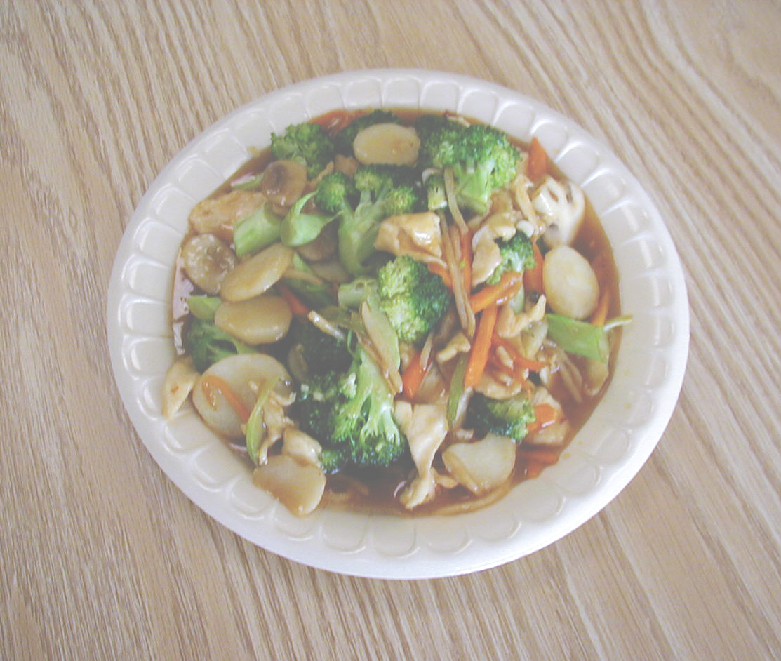
EMPRESS CHICKEN
BONELESS CHICKEN
YU-SHANG CHICKEN
PORK

